**Science communication 插图版**

在推进项目的同时，我们也努力向社会宣传我们的项目和iGEM大赛。我们致力于向群众科普专业的生物知识，带领研习生物领域的高校新生快速入门。

As we moved forward with our project, we strove to promote our project and the iGEM competition to the community. We were committed to educating the public about professional biology and leading freshmen in the field of biology to get started.

## Summary

在科学传播方面，我们既是传播者，也是接受者。我们将我们所学努力传递给群众与各阶段的学生，以帮助他们了解生物知识与技术；同时，我们接受了来自教授、老师、高校对于学术上的帮助，使项目得以不断完善，建立了氛围良好的学术圈子。我们接受先进的学术知识，将它们“分拣”给更广泛的群体。毫无疑问，我们是科学传播的重要一环

In science communication, we are not only spreader, but also receiver. We try our best to deliver what we have learned to people and students at various stages to acquire biological knowledge and technique. Meanwhile, we received academic help from professors, teachers, and colleges, which made the project more perfect. We also set up a favorable community. Here, we obtain advanced knowledge, and then 'deliver' them to wider population. Without doubt, we play an important role in science communication.

## Communication

### Media Publicity

微信公众号作为一种新媒体被我们用来进行科学传播。我们在ZJUTiGEM的公众号上累计发布推文16篇，累计关注人数达461人。推文专注于介绍我们团队以及知识科普。我们希望我们的公众号推文能体现出我们项目的成长性，让关注我们公众号的人都能通过推送实时的知道我们的项目进展。我们还在视频号、bilibili等平台投放我们的宣传视频以及vlog，取得了不错的成效。

We promote our project through social media platforms like Wechat. We have accumulated 16 tweets on ZJUT-China's WeChat official accounts, with a cumulative total of 461 followers. Our tweets focused on the introduction of our team and knowledge of science. We also placed our promotion videos and vlogs on other social media platforms and achieved good results.

The right-down is one of our tweets!

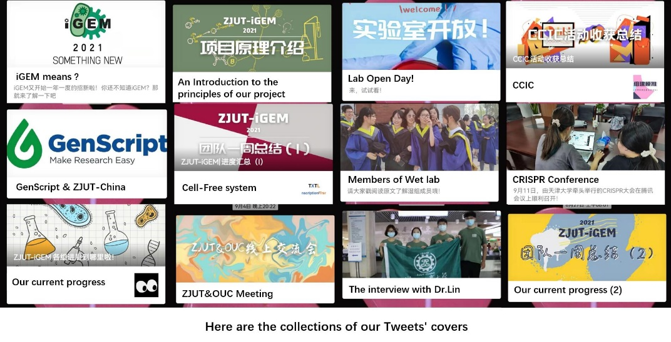

### BIO+ Innovation & Entrepreneurship

我们协助开展“生物+”国际青年科技作品展评大会相关工作，和组委会的老师积极沟通，以iGEM团队的身份与全国共65所高校团队取得联系，为活动的开展尽一份力。

We assisted in the implementation of the BIO+ innovation & entrepreneurship, and actively communicated with the teachers of the organizing committee to contact a total of 65 university teams nationwide as the iGEM team to do our part in the implementation of the event.



### Experts

我们在查阅文献时产生了一些疑惑，通过邮件，我们与多位专家沟通，他们的回信给予了我们很大的帮助。除了线上沟通之外，我们还有幸请到了中国科学院院士，厦门大学副校长韩家淮教授。韩教授为我们解决了基因线路设计方面的问题，同时对我们的项目进行了整体评估并提出了宝贵意见。

We had some doubts while reviewing the literature and through emails we communicated with several experts. Their replies were of immense help to us. In addition to the online communication, we were honored to have Prof. Jiahuai Han, academician of the Chinese Academy of Sciences and vice president of Xiamen University. Prof. Han solved our problems on gene circuits, evaluated our project and gave us valuable suggestions.

### Project Promotion Meeting

我们分别于5月和9月召开了一次项目推进会，以期为项目精准定位，更好的推动项目后续进程。我们邀请了浙江工业大学生物工程学院的葛璟燕教授、程峰教授等人为项目提出宝贵建议。在5月的项目推进会中，我们着重汇报了团队人员组成以及前期任务分工情况，介绍我们项目的工作进展以及目前存在的一些问题。老师们针对我们项目整体上的问题，提出了建设性意见。9月的推进会主要围绕着各组暑期内容汇总展开，同时探讨了项目最终的展示思路。

项目推进会后，我们完善了项目后续工作，加快湿组实验进程，同时对于阶段工作进行归纳总结，做好资料的规整。

In May and September, we hold the project promotion meeting, hoping to make the projecet have an accurately position and better promotion of the follow-up process. We invited Professor Jingyan Ge and Professor Feng Cheng from the bioengineering college of Zhejiang University of Technology to give valuable suggestions for the project.In the project promotion meeting in May, we reported the composition of team members and the division of tasks in the early stage, introduced the work progress of our project and some problems. The teachers made constructive comments to our project. The promotion meeting in September mainly focused on summarizing the contents of each group during the summer vacation, and discussed the final presentation ideas of the project.

### Lab Meeting

8月9日，我们邀请到团队指导老师葛璟燕老师和孙东昌老师莅临实验室.在交谈中，老师针对目前遇到的实验瓶颈提出了建设性意见，利用他们的专业知识为我们的项目指明了方向。

实验室小会结束后，我们总结实验失败经验，查阅文献，创新实验思路，完成项目指标。

On August 9, we invited team advisor teacher Jingyan Ge and Dongchang Sun to our lab. We were helped to solve several experimental bottkeneck problem problems by the guidance of their professional knowledge.

After the lab meeting, we summarized experience of failure and consulted literature to innovate the experimental ideas, and completed the project targets.

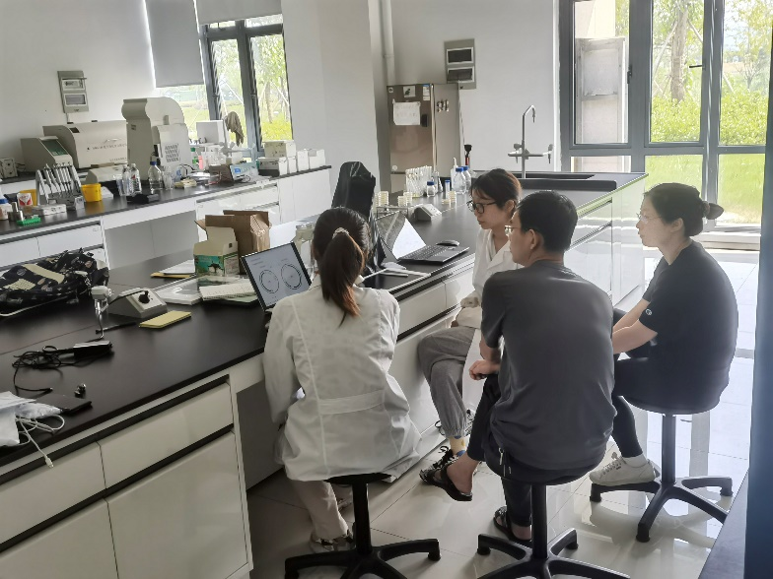

### Acdamitic Seminar

iGEM赛程中，我们不是孤独的队伍。我们与各个高校的iGEM队伍展开了密切交流，与XJTLU-iGEM,OUC-China，ASTWS-China举行了线上会议。各队伍对项目进行了热烈讨论，在相互交流中受益匪浅。

如果您想详细了解我们的学术交流会，请前往patnership板块阅读。

We are not lonely in iGEM. We have carried out close communication with iGEM teams from various universities and held online meetings with XJTLU-IGEM, OUC-China and ASTWS-China. The teams had a energetic discussion on the project and benefited a lot from mutual communication.

**If you want to learn the detail of our seminar, please browse *patnership.***

## Education

### Study Forum

5月9日，我们团队参加了浙江工业大学学而论坛，为所有屏峰校区大一新生作讲座。讲座内容包括iGEM大赛介绍、ZJUT-China本届与往届项目机理介绍。

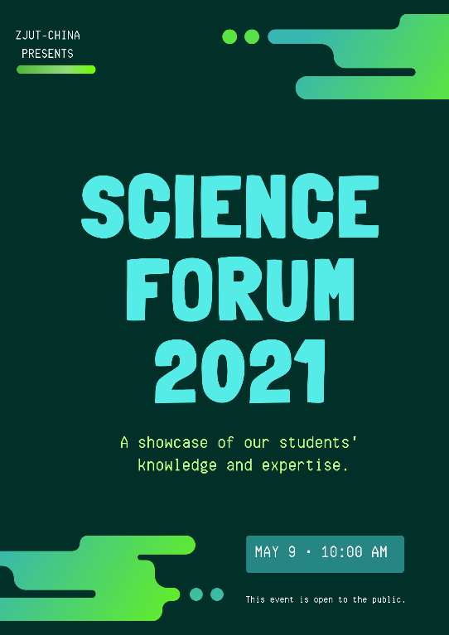On May 9th, our team participated in ZJUT Study Forum, giving a lecture to all the freshmen on the Pingfeng campus. The lecture included the introduction of iGEM competition, and the introduction of ZJUT-China team's current and previous project mechanism.

### High School Summer Camp

8月29日，我们参与了生物工程学院面向高中的暑期夏令营活动，向他们展示了丰富的大学生活以及我们的项目。鉴于高中生已经接受了基础的合成生物学知识教育，我们在PPT中使用了高中课本包含的知识对项目机理进行了解释，收获了高中同学们的一致好评。

On August 29, we participated in summer camp for high school students to show them the colorful college life and the mechanism of our project. Given that high school students have been taught basic synthetic biology knowledge, we used the knowledge contained in the high school textbook to explain the project mechanism in the PPT, which was well received by the high school students.

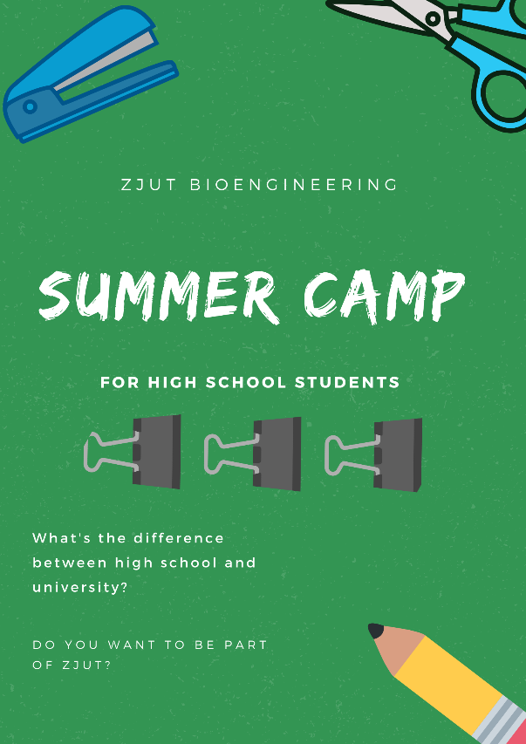

### Lab Open Day

9月11日，我们针对新生开展了实验室开放日的活动，我们为该次实验开放日分别准备了四个项目，分别为实验室仪器参观、点样与跑胶、配置培养基以及移液器的使用。开放日旨在通过实验与仪器讲解，培养大一新生对专业知识的兴趣，使其获得理论与实践的共同促进，更快的融入生物专业学习。开放日总计参与人数达140余人。

On September 12, we held a lab open day for freshmen. We prepared four separate programs: lab tour, agarose gel electrophoresis, use of pipettes and Culture media preparation. The open day aims to cultivate freshmen's interest in professional knowledge through experiments and instrument explanations. So that they can obtain the joint promotion of theory and practice, and integrate into the study of biology more quickly. Total number of participants reached more than 140 people.

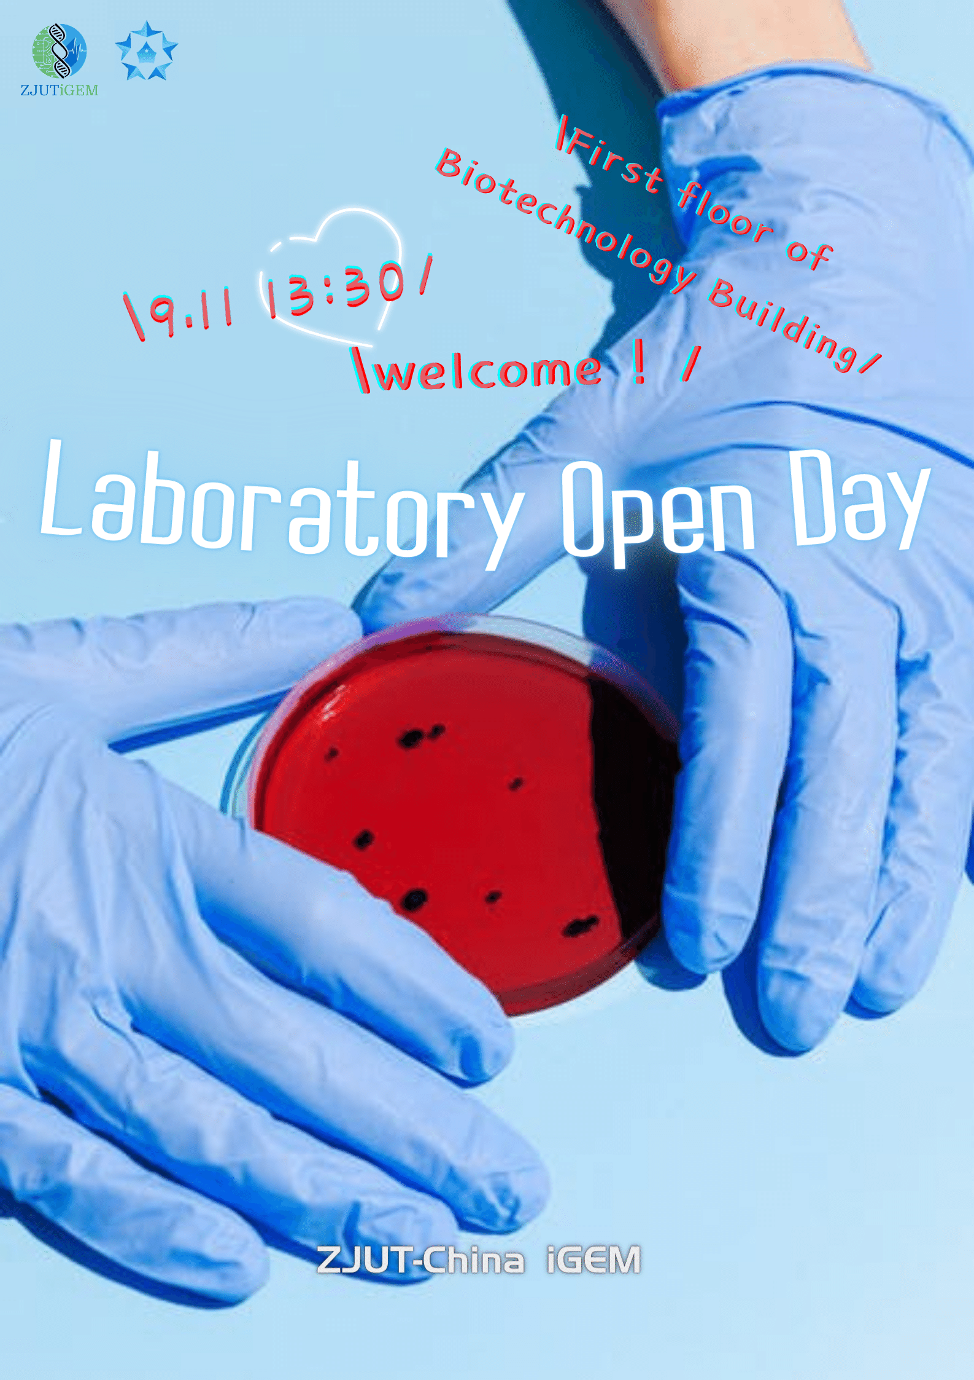

### Qiushan Primary School

9月28日，为了向低龄人群更早地传递了“生物”的概念，我们为秋山小学4年级学生们准备了一节不在课表上的“生物课”。课程用PPT与表演相结合的形式，生动地向孩子们解释了DNA和变异的基本概念，为他们解答了稚嫩的生物问题，如为什么自己长得像父母，为什么鸡生不出老虎。我们还与孩子们一起制作寨卡病毒纸模，让孩子们对微生物的外形有了基本的概念。

On September 28, we prepared a special biology lesson for grade 4 students of Qiushan Primary School. The basic concepts of DNA and variation are vividly explained to children through the combination of PPT and performance. We answered their childlike biology questions and made paper models of Zika virus with them, it gave them a basic idea of the appearance of microorganisms.

